SCHOOL OF COMPUTER SCIENCE AND ARTIFICIAL INTELLIGENCE |  |  |  |  | DEPARTMENT OF COMPUTER SCIENCE ENGINEERING
Program Name: B. Tech |  |  |  | Assignment Type: Lab |  |  | Academic Year:2025-2026
Course Coordinator Name |  |  |  | Venkataramana Veeramsetty
Instructor(s) Name |  |  |  | Dr. V. Venkataramana (Co-ordinator)  Dr. T. Sampath Kumar  Dr. Pramoda Patro  Dr. Brij Kishor Tiwari  Dr.J.Ravichander  Dr. Mohammand Ali Shaik  Dr. Anirodh Kumar  Mr. S.Naresh Kumar  Dr. RAJESH VELPULA  Mr. Kundhan Kumar  Ms. Ch.Rajitha  Mr. M Prakash  Mr. B.Raju  Intern 1 (Dharma teja)  Intern 2 (Sai Prasad)  Intern 3 (Sowmya)  NS_2 ( Mounika)
Course Code |  |  | 24CS002PC215 | Course Title |  | AI Assisted Coding
Year/Sem |  |  | II/I | Regulation |  | R24
Date and Day  of Assignment |  |  | Week6 - Monday | Time(s)
Duration |  |  | 2 Hours | Applicable to  Batches
Assignment Number:19.5(Present assignment number)/24(Total number of assignments)
 | Q.No. | Question |  |  |  |  |  | Expected Time  to complete
 | 1 | Lab 19 – Code Translation: Converting between programming languages  Lab Objective  The objective of this lab is to familiarize students with AI-assisted code translation across programming languages. Students will:  - Understand the challenges of syntax, semantics, and library differences when converting code between languages.  - Learn to use AI coding assistants to generate equivalent code in another language, while critically evaluating the correctness and efficiency of the translated version.  - Practice debugging and refining translated code to ensure functional equivalence and error-free execution.  - Develop the skill to create cross-language solutions, preparing students to work in diverse programming environments.  Lab Question 1: Sorting Algorithm Translation  You are part of a multinational development team. The backend is written in Java, but a new module requires a Python implementation of the same algorithm for integration with a data science pipeline.  - Task 1: Use AI-assisted coding to translate a given Java bubble sort program into Python. Verify that the translated code works correctly.  - Task 2: Introduce errors in the Python version to check if the input list is empty or contains non-numeric values.  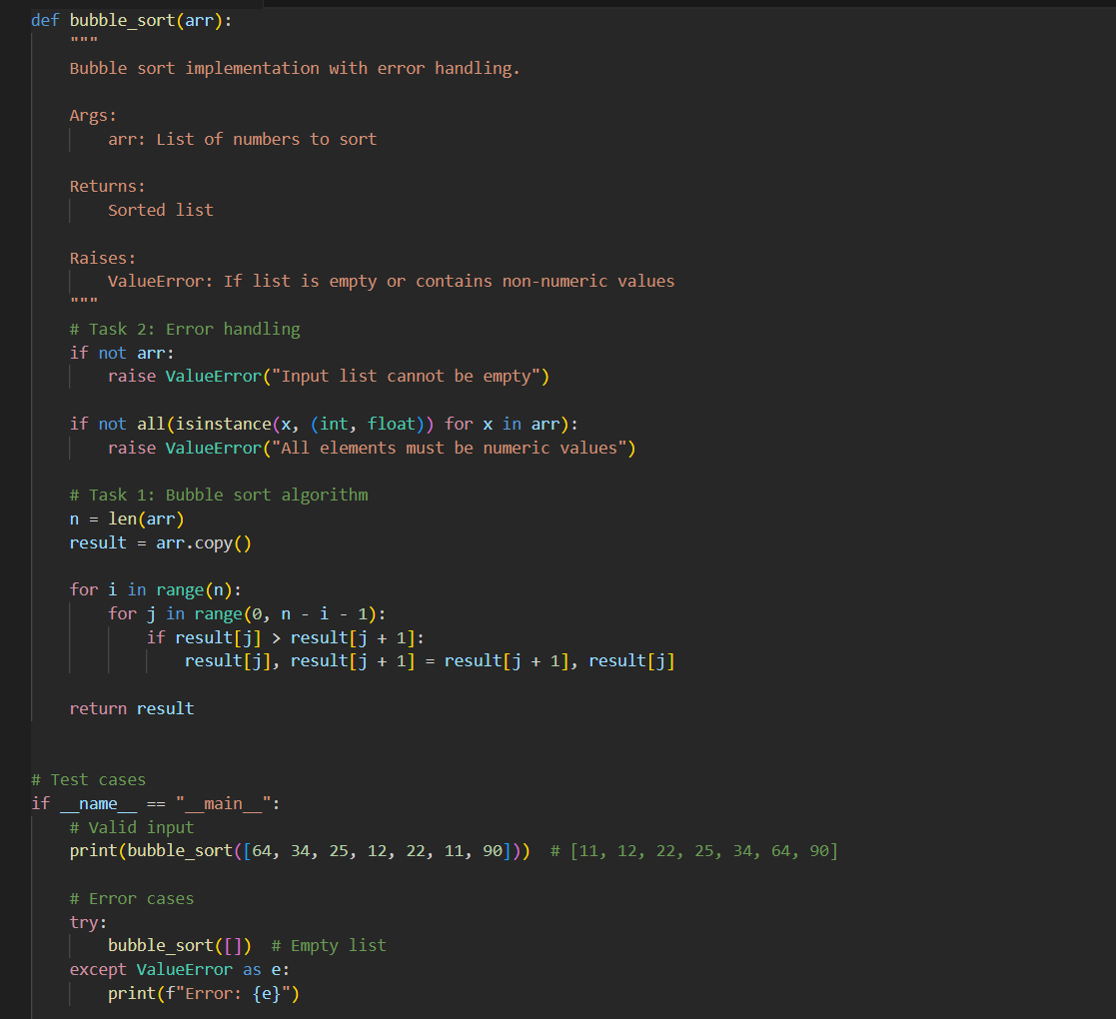  Lab Question 2: File Handling Translation  A company’s legacy codebases stores and processes files in C++, but the analytics team needs an equivalent program in JavaScript (Node.js) for integration with a web dashboard.  - Task 1: Translate a given C++ file read-and-write program into JavaScript using AI assistance. Ensure the script reads a text file and writes processed output to a new file.  - Task 2: Add error handling in the JavaScript version to gracefully handle missing files or permission errors.  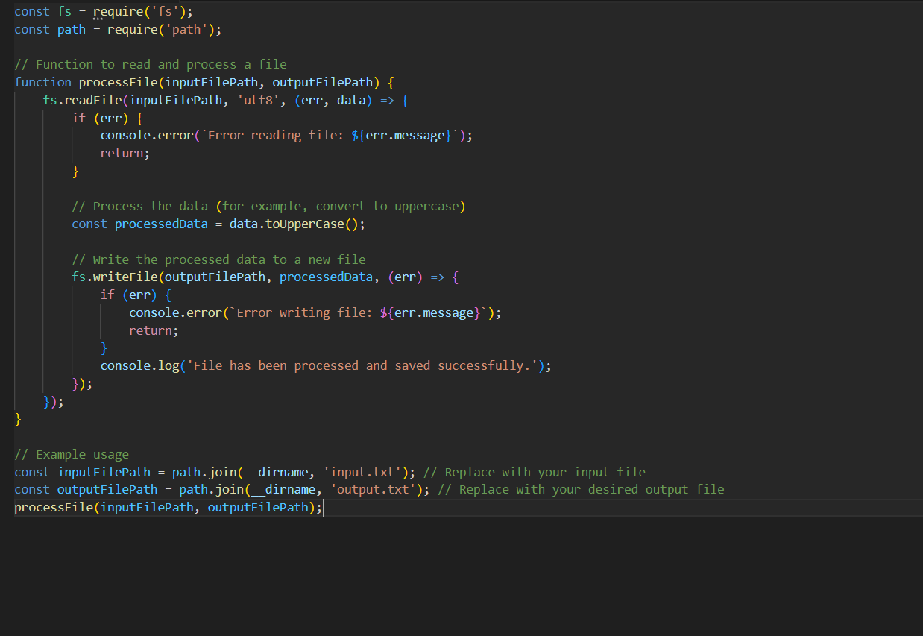  Lab Question 3: API Call Translation  Your team developed a prototype in Python to fetch weather data from an API, but the production environment only supports Java.  - Task 1: Translate the Python script (that makes an API call and prints the response) into Java using AI-assisted coding. Ensure equivalent functionality.  - Task 2: Add proper error handling in the Java version for cases such as invalid API key, request timeout, or no internet connection.  - 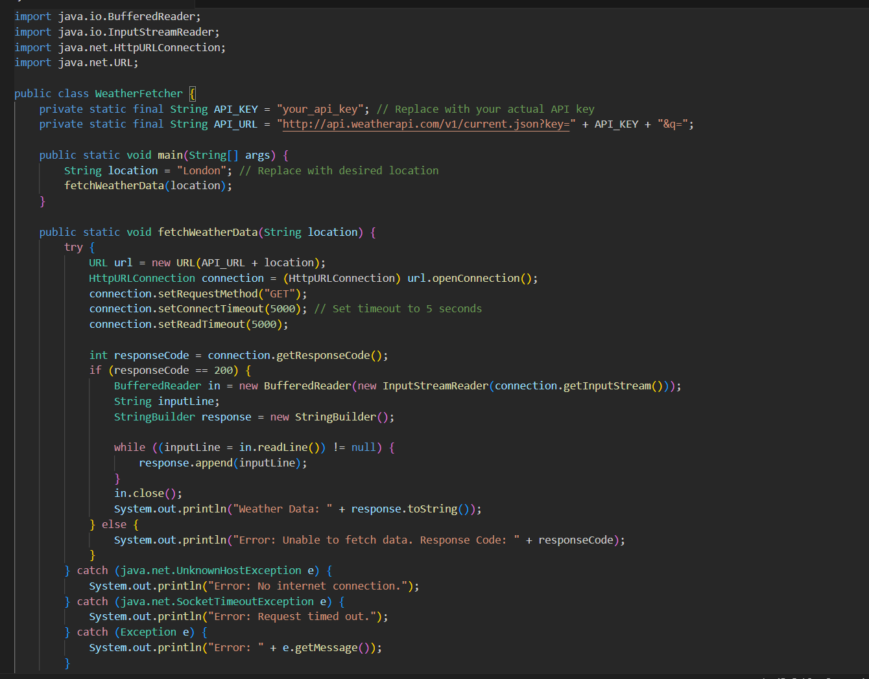 |  |  |  |  |  | Week 10 - Friday

